Bahria University

Karachi Campus



COURSE: SEN-448 Software Application for Mobile Devices

TERM: SPRING 2020, CLASS: BSE- 6(A)

**PROJECT NAME**

51739 Uzair Mehmood

51777 Noman Ali Siddique

Engr. Adnan ur Rehman / Engr. Misbah Perveen

Signed Remarks: Score:

Table of Contents

INTRODUCTION 3

PROBLEM 3

PROJECT DISCRIPTION 3

ELEMENTS USED (with proper description) 5

Linear Layout 5

Relative Layout 5

Scroll View 5

List View 5

Radio Group 5

Radio Button 5

Edit Text 5

Text View 5

Textbox 5

Button 5

PROJECT WALKTHROUGH 6

CONCLUSION 8

SCOPE FOR FUTURE DEVELOPMENT 8

Project Link 8

# INTRODUCTION

attendance management system deal with the maintenance of the student’s attendance details. It is generating the attendance of the student on basis of presence in class. It is maintaining daily basis of attendance; the staff will be provided with the separate username and password to make student attendance. The staff handling the particular subject to responsible to make the attendance for all students. Only if the student presents the particular date, the attendance will be calculated.

Analysis can be defined as breaking up of any whole so as to find out their nature, function etc. It  
defines design as to make preliminary sketches of; to sketch a pattern or outline for plan. To plan and  
carry out especially by artistic arrangement or in a skillful wall. System analysis and design can be  
characterized as a set of techniques and processes, a community of interests, a culture and an intellectual  
orientation. The various tasks in the system analysis include the following.  
Understanding application.  
Planning.  
Scheduling.  
Developing candidate solution.  
Performing trade studies.  
Performing cost benefit analysis.  
Recommending alternative solutions.  
Supervising, installing and maintaining the system.  
This system manages to the analysis of the report creation and develops manual entry of the student  
attendance. First design the student’s entry form, staff allocation and time table allocation forms. This  
project will help the attendance system for the department calculate percentage and reports for  
eligibility criteria of examination. The application attendance entry system will provide flexible report  
for all students.

# PROBLEM

Existing system is a manual entry for the students. Here the attendance will be carried out in the hand written registers. It will be a tedious job to maintain the record for the user. The human effort is more here. The retrieval of the information is not as easy as the records are maintained in the hand written registers.  
This application requires correct feed on input into the respective field. Suppose the wrong inputs are  
entered, the application resist to work. so the user find it difficult to use.

# PROJECT DISCRIPTION

* Add Student.
* Add Faculty.
* View Student.
* View Teacher.
* View Student Attendance.
* View each student’s attendance separately

**Teacher Module**

* Take attendance and keep them class wise
* Add New student. View each student’s attendance separately
* Edit Student/Attendance later
* Save notes subject wise
* Simple designed interface

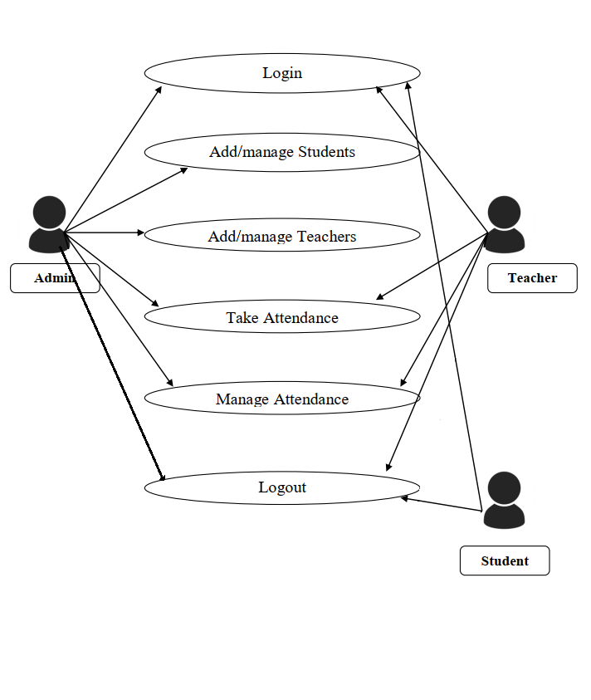

# ELEMENTS USED (with proper description)

## Linear Layout

Linear layout is a simple layout used in android for layout designing. In the Linear layout all the elements are displayed in linear fashion means all the child’s/elements of a linear layout are displayed according to its orientation. The value for orientation property can be either horizontal or vertical.

## Relative Layout

Android Relative Layout enables you to specify how child views are positioned relative to each other. The position of each view can be specified as relative to sibling elements or relative to the parent.

## Scroll View

Scroll View is a kind of layout that is useful to add vertical or horizontal scroll bars to the content which is larger than the actual size of layouts such as linear layout, relative layout, frame layout,Spinner etc.

Spinners provide a quick way to select one value from a set. In the default state, a spinner shows its currently selected value. Touching the spinner displays a dropdown menu with all other available values, from which the user can select a new one.

## List View

Android List View. Android List View is a view which groups several items and display them in vertical scrollable list. The list items are automatically inserted to the list using an Adapter that pulls content from a source such as an array or database.

## Radio Group

This class is used to create a multiple-exclusion scope for a set of radio buttons. Checking one radio button that belongs to a radio group unchecks any previously checked radio button within the same group.

## Radio Button

To create each radio button option, create a Radio Button in your layout. However, because radio buttons are mutually exclusive, you must group them together inside a Radio Group*.* By grouping them together, the system ensures that only one radio button can be selected at a time.

## Edit Text

Edit Text is a standard entry widget in android apps. It is an overlay over Text View that configures itself to be editable. Edit Text is a subclass of Text View with text editing operations

## Text View

Text View with Example in Android Studio. In Android, Text View displays text to the user and optionally allows them to edit it programmatically. Text View is a complete text editor, however basic class is configured to not allow editing but we can edit it. View is the parent class of Text View.

## Textbox

Used to get text from user.

## Button

A button consists of text or an icon (or both text and an icon) that communicates what action occurs when the user touches it.

# PROJECT WALKTHROUGH

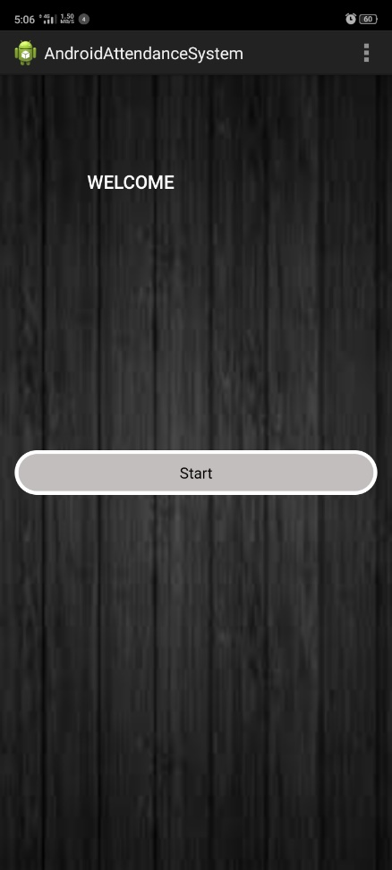 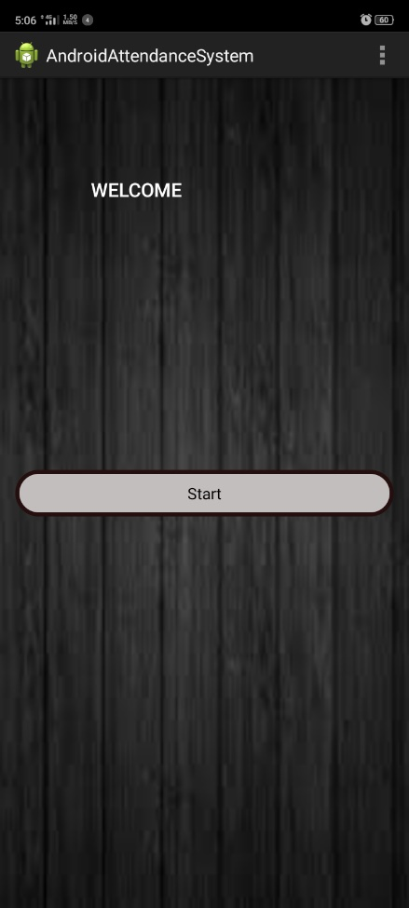 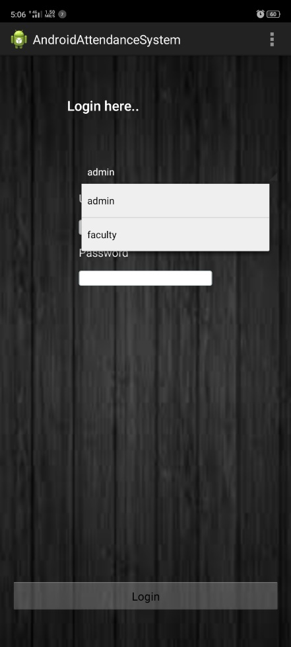

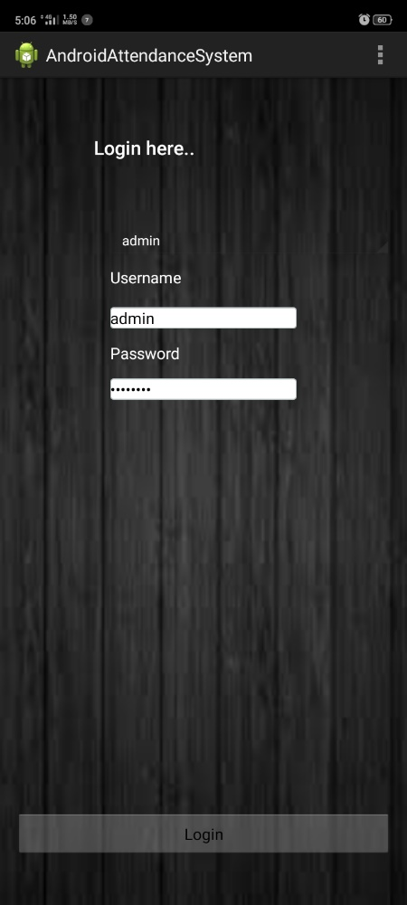 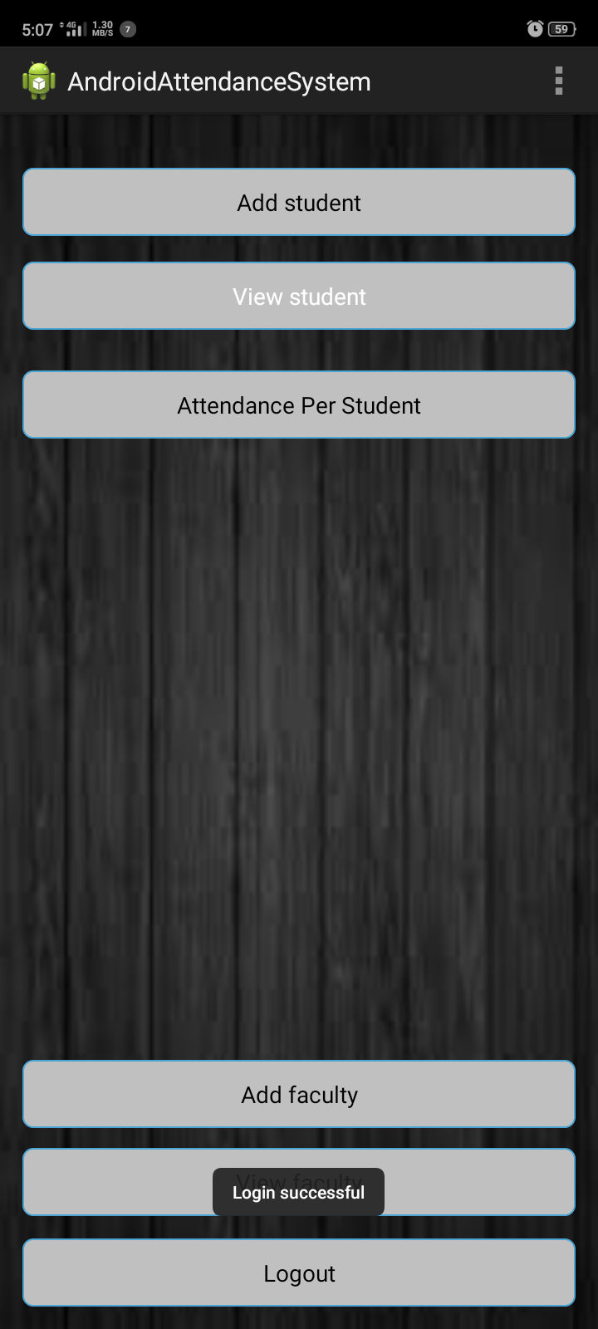 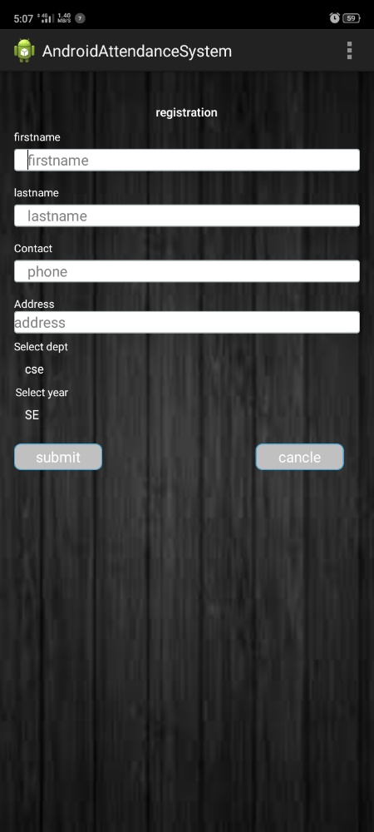

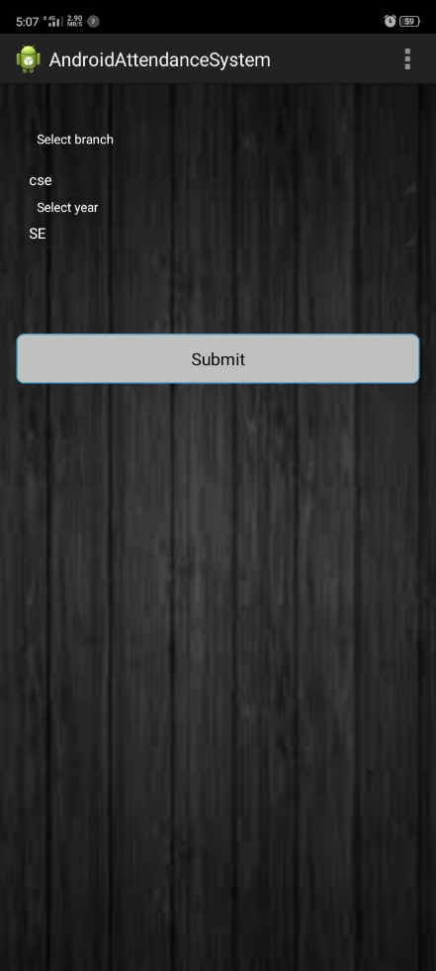 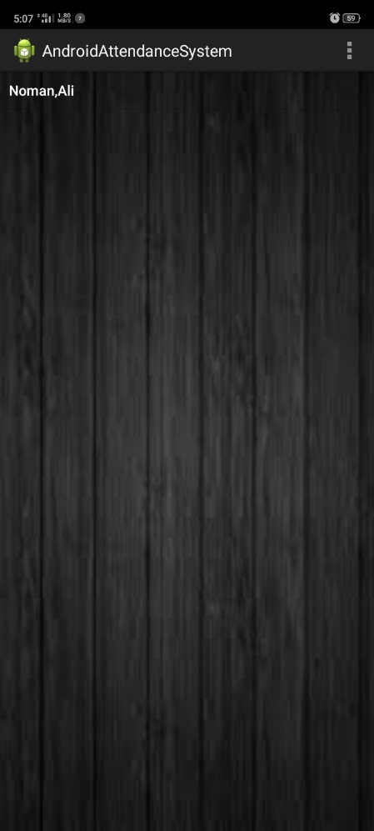 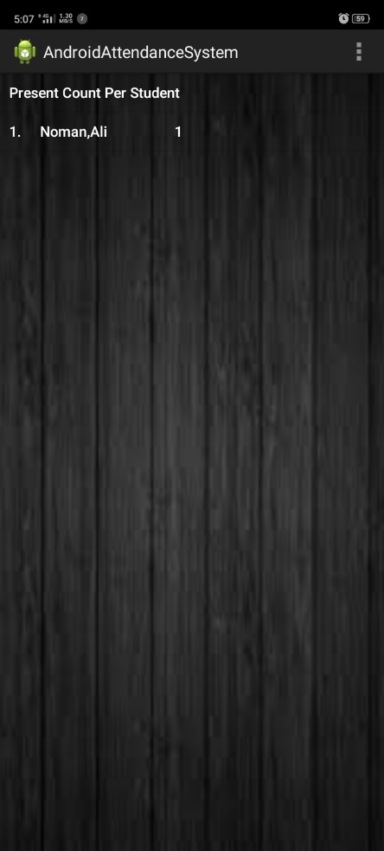

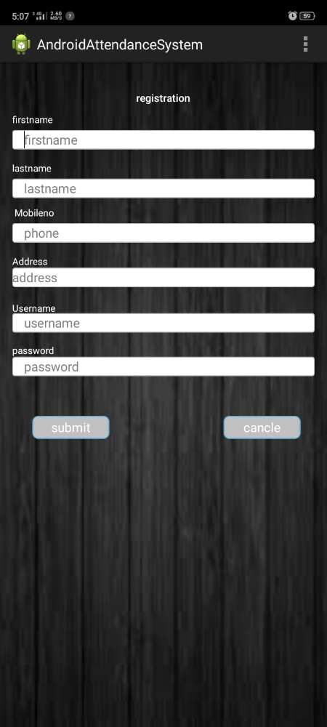 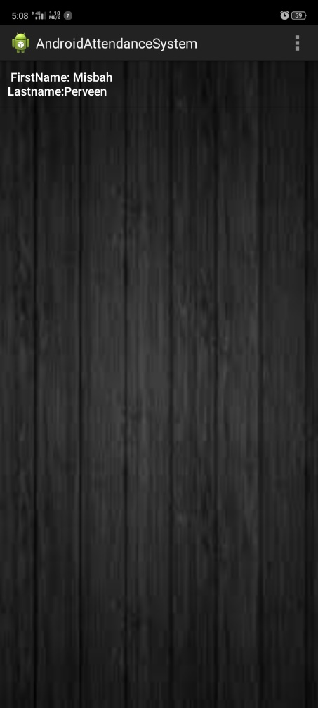 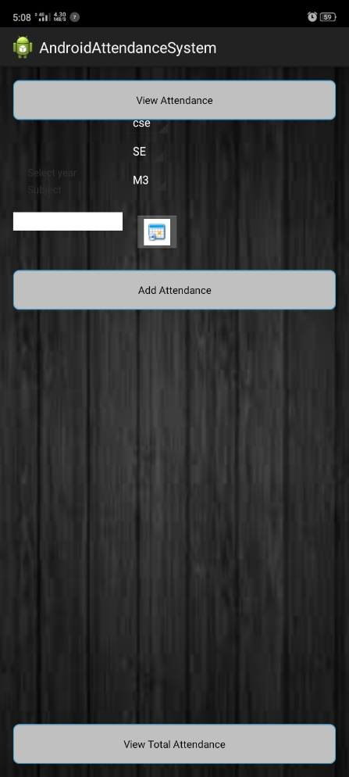

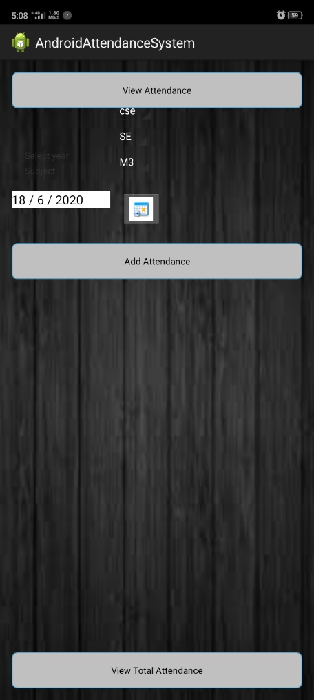 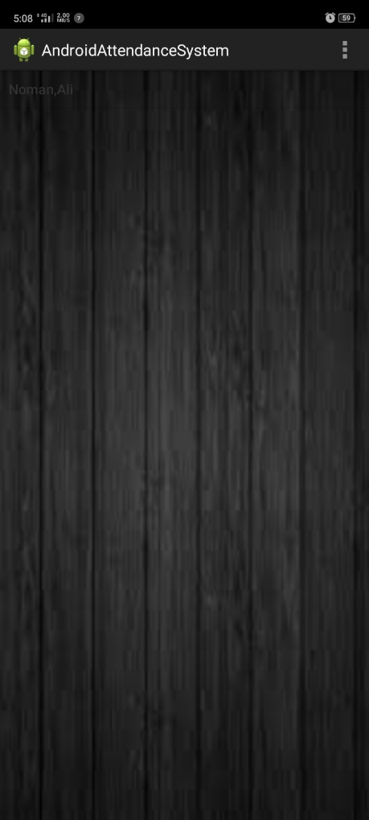 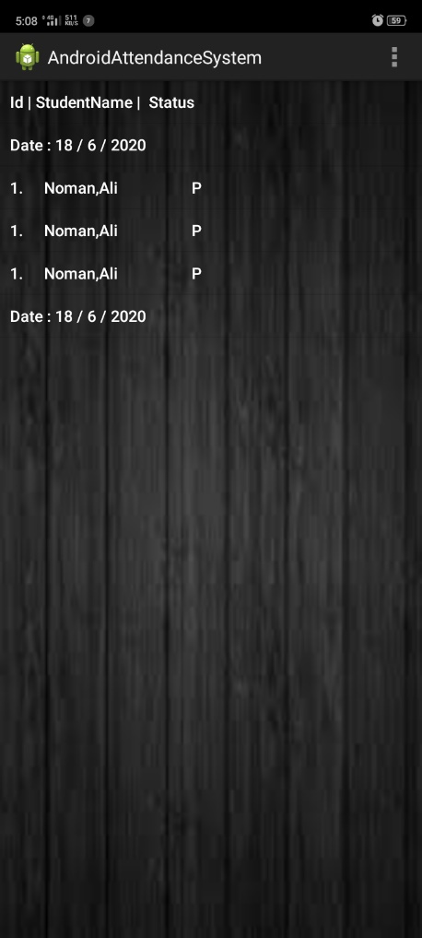

# CONCLUSION

The Attendance Management System is developed using Android Studio fully meets the objectives of  
the system which it has been developed. The system has reached a steady state where all bugs have been  
eliminated. The system is operated at a high level of efficiency and all the teachers and user associated  
with the system understands its advantage. The system solves the problem. It was intended to solve as  
requirement specification.

# SCOPE FOR FUTURE DEVELOPMENT

The project has a very vast scope in future. The project can be implemented on intranet in future. Project  
can be updated in near future as and when requirement for the same arises, as it is very flexible in terms  
of expansion. With the proposed software of database Space Manager ready and fully functional the  
client is now able to manage and hence run the entire work in a much better, accurate and error free  
manner.

## Project Link

Project is Available [here](https://github.com/IAMUZAIRMEHMOOD/Software-Application-For-Mobile-Devices-20)